Treaty of Mutual Recognition

between

SOVEREIGN MILITARY ORDER
OF TEMPLE OF THRONE BLESSED VIRGIN OF GALICIA,
THE EMPERORS OF EAST AND WEST –
GUARDIANS OF THE ROYAL SILENCE

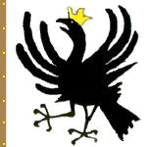

and

THE AERICAN EMPIRE

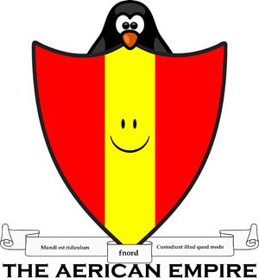
The two signing nations, wishing to formalize their ongoing efforts towards peaceful cooperation and coexistence, affirm mutual recognition and agree between them to open diplomatic relations

For Sovereign Military Order  of Temple of Throne Blessed Virgin Of Galicia,  The Emperors of East and West –  Guardians of the Royal Silence:  Knight-steward,  Grand Prior of Estland and Fennoscandia,  Grand Chancellor of the Varangian,  Baltic and Pomeranian lands,  Castellan of Both Galittens,  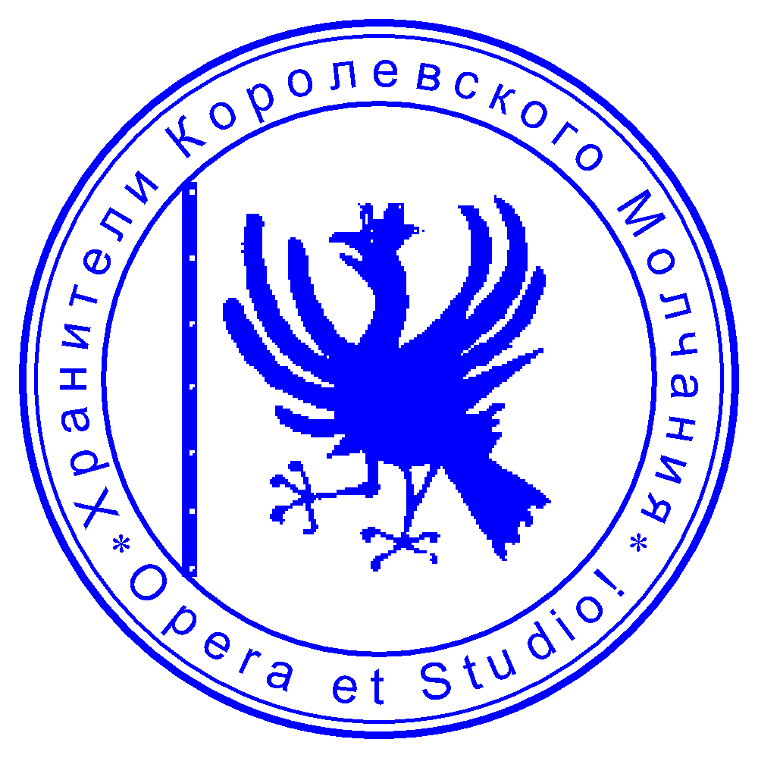    Roman Utter-Adrianov | For the Aerican Empire:  Digitally signed by HE Tristan Glark  2023/10/15 at 14:06 EST  HE Tristan Glark  Minister of Diplomacy and Foreign Affairs

